**Hands on Exercise**

You will configure vertical navigation with an unordered list in this Hands-On Practice. Create a folder named ch7vert. Copy the files lighthouseisland.png, lighthouselogo.png, and starter3.html from the chapter7 folder in the student files into your ch7vert folder. Display the web page in a browser. It should look similar to [**Figure 7.22**](https://jigsaw.vitalsource.com/books/9780133971026/epub/OPS/xhtml/fileP7000495062000000000000000002178.xhtml#P70004950620000000000000000021A4)—notice that the navigation area needs to be configured.

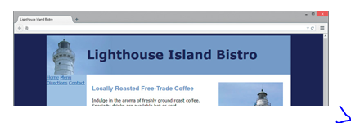

**Figure 7.22 *Notice that the navigation area needs to be configured.***

Launch a text editor and open the starter3.html file. Save the file as index.html in your ch7vert folder.

1. Review the code for this page, which uses a two-column layout. Examine the nav element and modify the code surrounding the hyperlinks to configure the navigation in an unordered list.
2. <nav>
3. <ul>
4. <li><a href="index.html">Home</a></li>
5. <li><a href="menu.html">Menu</a></li>
6. <li><a href="directions.html">Directions</a></li>
7. <li><a href="contact.html">Contact</a></li>
8. </ul>

</nav>

1. Let’s add CSS to the embedded styles to configure the unordered list elements only within the nav element: eliminate the list marker and set the padding to 10 pixels.
2. nav ul { list-style-type: none;

padding: 10px; }

1. Next, configure the anchor tags within the nav element to have 10 pixels of padding, use bold font, and display no underline.
2. nav a { text-decoration: none;
3. padding: 10px;

font-weight: bold; }

Save your page and test it in a browser. Your page should look similar to [**Figure 7.23**](https://jigsaw.vitalsource.com/books/9780133971026/epub/OPS/xhtml/fileP7000495062000000000000000002178.xhtml#P70004950620000000000000000021BB).

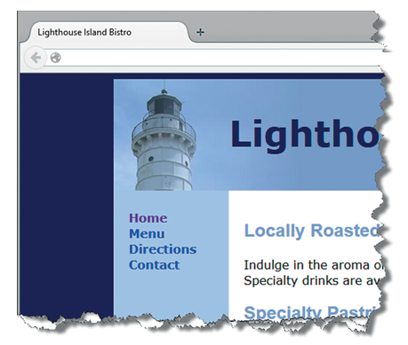

**Figure 7.23 *Two-column layout with vertical navigation.***